Product Report

SIDF |  Saudi Industrial Development Fund

PRODUCT REPORT - SULFOLANE

aLANOUD aLSAHLI

2024

# Product Information

## Definition

**Sulfolane** Also known as tetramethylene sulfone, is a clear, colorless liquid, readily soluble in water, and commonly used in the chemical industry as an extractive distillation solvent or reaction solvent and pharmaceuticals. It is a stable, water-miscible solvent that is widely used in chemical processing due to its excellent solvation properties, high boiling point, and thermal stability.

## Application

There are many applications for sulfolane including the following:

* **Gas Sweetening:** Used in removing acidic gases like CO₂ and H₂S from natural gas and refinery streams.
* **Aromatic Extraction:** Employed in the extraction of aromatics such as benzene, toluene, and xylene from hydrocarbon mixtures in petrochemical plants.
* **Chemical Manufacturing:** Used as a solvent in the synthesis of specialty chemicals and polymers.
* **Electronics Industry:** Plays a role in the production of high-purity solvents for the manufacturing of electronic components.
* **Pharmaceuticals:** Utilized as a solvent in drug synthesis and formulation.
* **Oil Refining:** Assists in the extraction of sulfur compounds and other impurities to improve fuel quality.

## Product Pictures

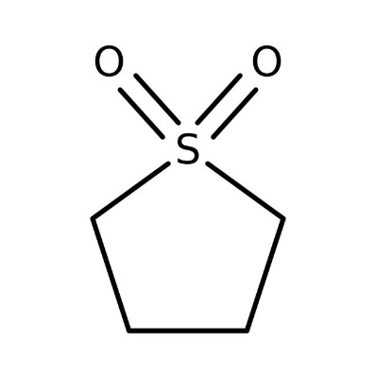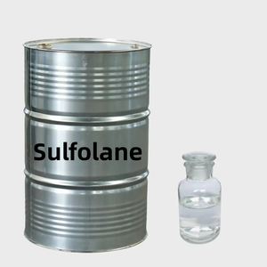

## Product Substitutes

Sulfolane have no product substitutes.

# Market Dynamic

## 2.1 Historical Supply/Demand

Specialized Chemical Solvent is the only producer of Sulfolane in the MENA region. The supply/demand during last 3 years with current installed capacity is as follows:

|  |  |  |  |  |  |
| --- | --- | --- | --- | --- | --- |
| Sulfolane | Installed Capacity (TPA) | 2021 | 2022 | 2023 | Utilization Rate 2023 |
| SAU1692 Specialized Chemical Solvent (Sponsor) | 6,000 | 399 | 438 | 708 | 7% |
| Imports (+) | | 3,600 | 3,780 | 3,969 | - |
| Exports (-) | | 255 | 371 | 490 |
| Local Demand | | 3,744 | 3,847 | 4,187 |
| Growth Rate % | | - | 3% | 9% |
| Comments:  Specialized Chemical Solvent is the first and only company in the MENA region producing Sulfolane from Sulfuric acid as part of its chemical synthesis process. However, the plant's production has been low due to the imported raw material, Butadiene, not meeting specifications. This has affected the plant's operational efficiency | | | | | |

## 2.2 Future Demand/Balance

The following table shows supply & demand balance for the subject product in the Saudi Market during the next following years: -

|  |  |  |  |  |  |  |  |
| --- | --- | --- | --- | --- | --- | --- | --- |
| **Year (Ton)** | **2024 (Annualized)** | **2025** | **2026** | **2027** | **2028** | **2029** | **2030** |
| **Sulfolane** | | | | | | | |
| Local Supply | 6,000 | 6,000 | 6,000 | 6,000 | 6,000 | 6,000 | 6,000 |
| Local Demand (5%) | 4,477 | 4,701 | 4,936 | 5,183 | 5,442 | 5,714 | 6,000 |
| Exports (5%) | 175 | 184 | 193 | 203 | 213 | 224 | 175 |
| Balance | 1,348 | 1,115 | 871 | 614 | 345 | 62 | -175 |
| **Comments:**  MSD estimated the demand to grow by 5% for Sulfolane and Sulfuric Acid until 2030. | | | | | | | |

# Porter Five Forces

**Threat of New Entry**

**Medium**

Dependence on raw materials like butadiene and sulfur compounds provides leverage to raw material suppliers.

**Competitive Rivalry**

**Moderate**

Moderate since

there are only two local suppliers but furious competition from cheaper imports originating from China.

-

-

**Power of Supplier**

**Low**

Due to Significant capital investment, regulatory hurdles, high maintenance cost and the need for advanced technology.

**Power of**

**Buyer**

**Moderate**

Buyers (petrochemical and natural gas companies) have moderate negotiating power due to limited suppliers and price sensitivity.

**Low**

There are no alternatives to sulfolane’s demand in certain applications.

**Threat of Substitutes**

# Price

The following table illustrates the market prices for Sulfolane

|  |  |  |
| --- | --- | --- |
| SR / Unit | Imports | Average Prices (2024) |
| Sulfolane | 16, 610 | 11,438 - 16, 610 |

Based on the UN Cometrade data (harmonized code 29309099) for Sulfolane , it reflects the global historical prices for the last three years:

|  |  |  |  |
| --- | --- | --- | --- |
| Year/SR | 2021 | 2022 | 2023 |
| Sulfolane | 16,003 | 20,001 | 16,610 |
| Growth Rate | - | 25% | -17% |

As it can be seen from the above table, global price of Sulfolane Acid has witnessed a dramatic increase in 2022 by 25% then declined in 2023 by -17%. This was due to global prices of raw materials (Sulfur).

# Product/Market Card

There are no substitutes for Sulfolane

**Substitute Product**

-Gas sweetening solutions

-Aromatic extraction

-Chemical manufacturing

-Electronics industry

-Pharmaceutical

-Oil refining

-Petrochemical industry: 50%-60% : Sulfolane’s primary application is in aromatic extraction, especially for benzene, toluene, and xylene separation.

-Natural Gas Processing: 25% - 30%

-Battery manufacturers: 5%-10%

-Pharmaceutical industry: 5%-7%

- The petrochemical industry and natural gas processing dominate sulfolane demand due to its critical use in extraction and sweetening processes.

-Emerging markets like battery manufacturers

**Customer Segmentation**

**Power of Customer**

**Demand Drive**

Product Market Card

# Marketing Success Factors

* **Sustainability:** Highlight environmentally friendly production methods to attract eco-conscious industries.
* **Cost-Effectiveness:** Emphasize energy efficiency and reduced processing times in industrial applications.
* **Regulatory Compliance:** Ensure the product meets international environmental and safety standards (e.g., REACH, EPA).
* **Customization:** Offer tailored solutions for specific industries like gas sweetening or aromatic extraction.
* **Strategic Partnerships:** Collaborate with natural gas processors, petrochemical companies, and battery manufacturers.

# International market Attractiveness

**Top 10 net importers of Sulfolane, their exports, and net imports during (2021-2023)**

**Share of top 10 net importers of Sulfolane compared to other countries during (2021-2023)**

**Top 10 exporters of Sulfolane during (2021-2023)**